ACTIVITY 1: BUSINESS USE CASE
ServiceNow – Incident Management
BUSINESS REQUIREMENTS
1. Automatically classify IT tickets based on the issue description.
2. Assign both Category and Subcategory without manual intervention.
3. Support dependent choice logic between Category and Subcategory.
4. Send an automated email notification to the caller upon ticket creation.
5. Store ticket information in a structured and standardized format.
6. Ensure easy maintenance and future scalability.
IMPLEMENTATION EVIDENCE
The following ServiceNow screenshots provide implementation evidence for the six business requirements. Each figure is labelled with the exact requirement it demonstrates.

1. Automatically classify IT tickets based on the issue description.
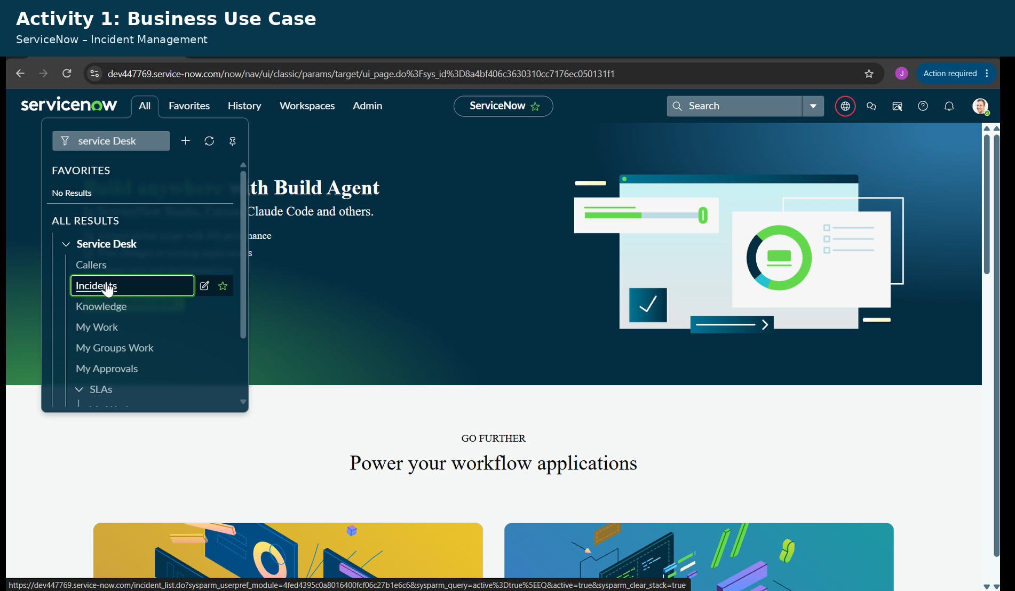
2. Assign both Category and Subcategory without manual intervention.
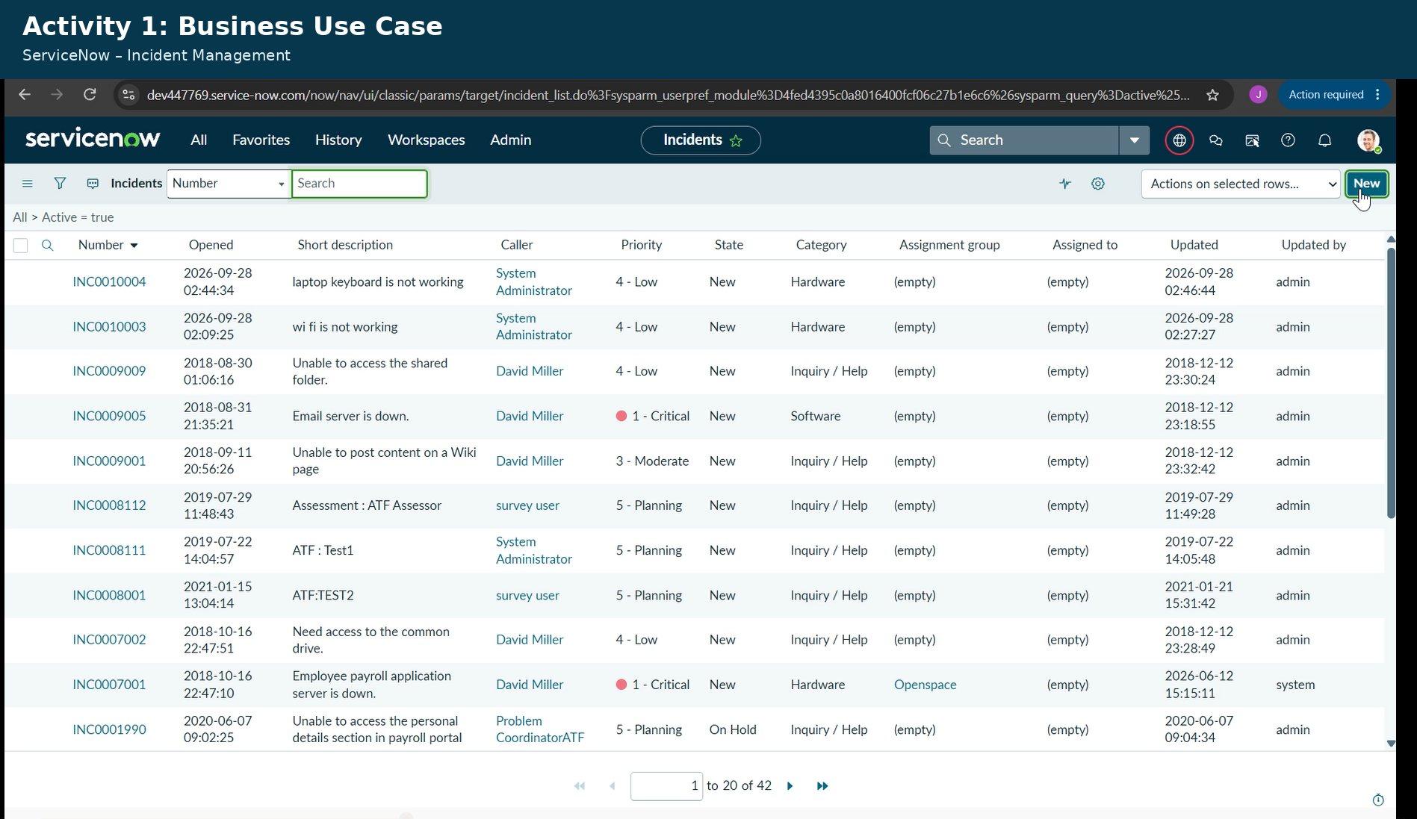

3. Support dependent choice logic between Category and Subcategory.
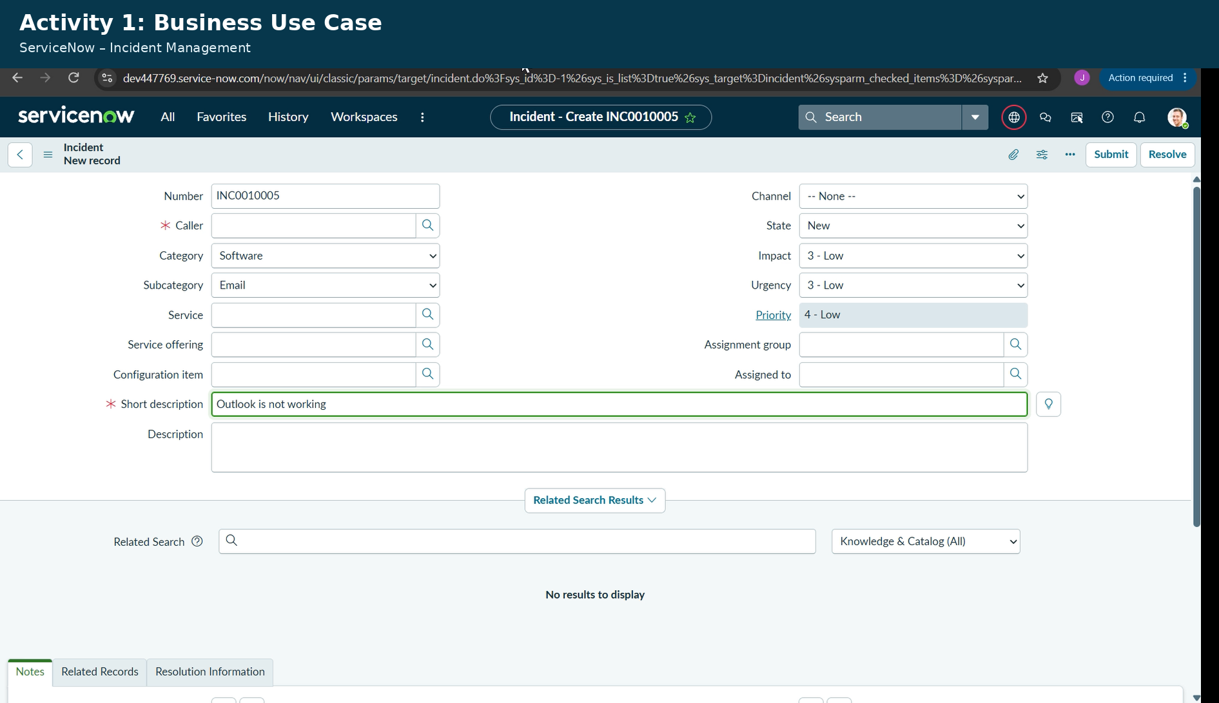
4. Send an automated email notification to the caller upon ticket creation.
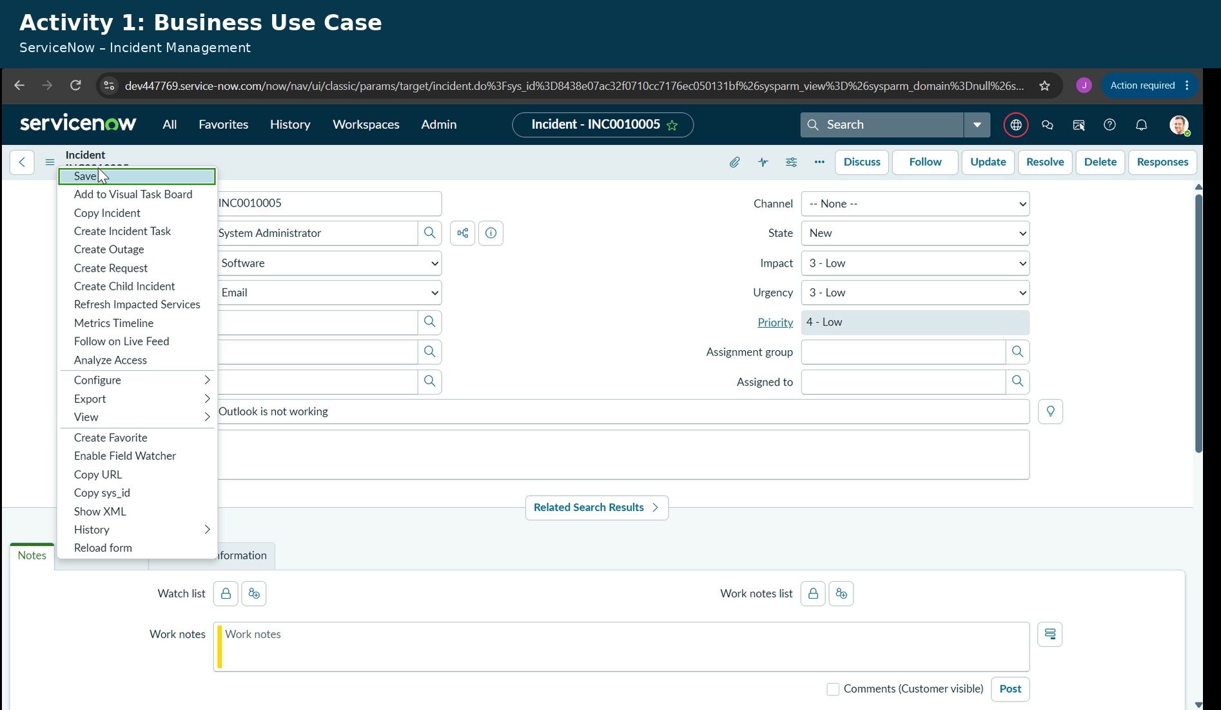

5. Store ticket information in a structured and standardized format.
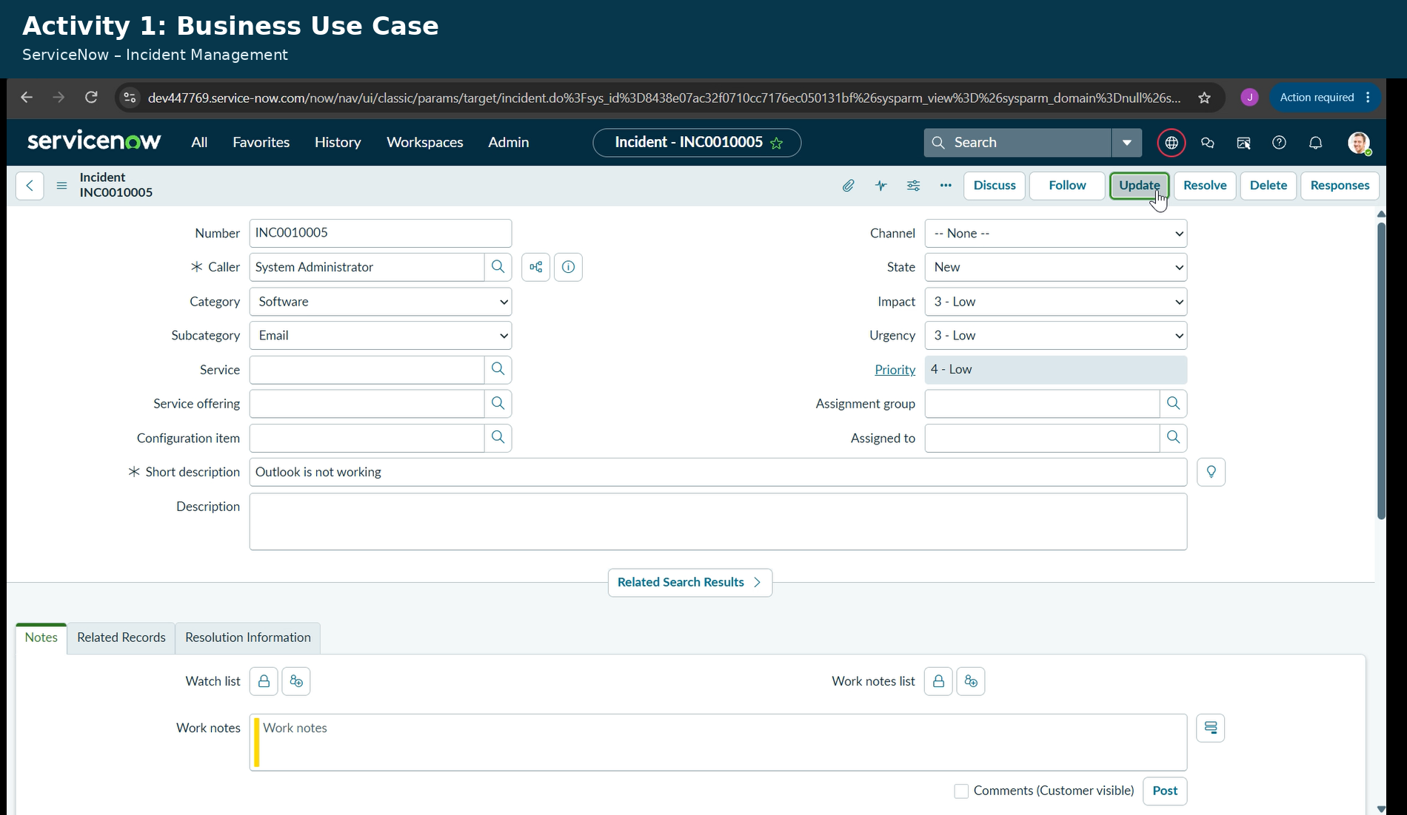
6. Ensure easy maintenance and future scalability.
